**Clean Architecture**

* **Installation**

1. **STEP – 1**

* **INSTALL visual studio 2022 community.**
* **Install MSSMS (Microsoft SQL Server Management Studio) for window platform.**

1. **STEP – 2**

* **Open VS and select 🡪 create new project.**
* **Select 🡪 Blank Solution.**
* **Set 🡪 project name and folder path.**

1. **STEP – 3**

* **Right Click on Project and add new folder. Folder name is 🡪 Core.**
* **Right Click on Core folder 🡪 add 🡪 new project.**
* **Select 🡪class library project and give name as Domain.**
* **Again, Right click on core folder 🡪 add 🡪 new project.**
* **Select 🡪class library project and give name as Application.**
* **Then Right click on main project 🡪 add 🡪 new project.**
* **Select 🡪class library project and give name as Infrastructure.**
* **Then Right click on main project 🡪 add 🡪 new project.**
* **Select 🡪ASP.NET WEB API CORE project and give name as WEB API.**

1. **SETEP – 4**

**Project Reference**

* **Right click on Application layer 🡪 add 🡪 project reference 🡪 tick the domain layer.**
* **Right click on infrastructure layer 🡪 add 🡪 project reference 🡪 tick the Application layer.**
* **Right click on WEB API layer 🡪 add 🡪 project reference 🡪 tick the infrastructure layer.**

1. **STEP – 5**

* **In Domain layer we are creating, or we are using for to create models and, we are storing in domain model.**
* **Nullable Settings**

1. **STEP – 6 (Nullable Settings)**

* **Just click on domain project. While opening a window, in that window we have to set disable as per below mentioned pic.**

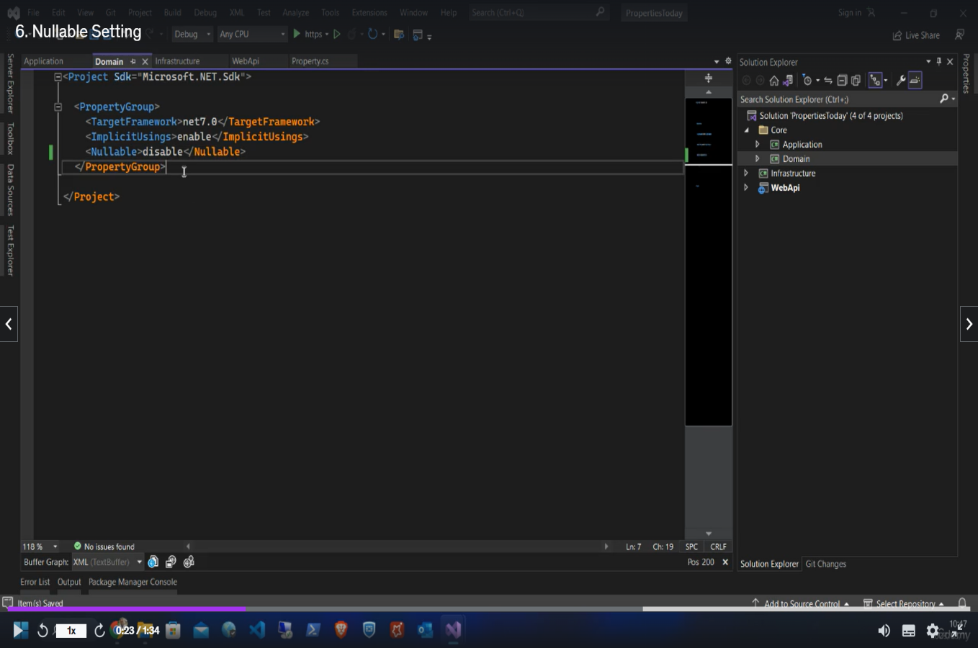

* **Just click on Application project. While opening a window, in that window we must set disable as per above mentioned pic.**
* **Just click on Infrastructure project. While opening a window, in that window we must set disable as per above mentioned pic.**
* **Just click on the WEB API project. While opening a window, in that window we must set disable as per above mentioned pic.**
* **Application Layer**
* **All business Logic things are happening under the Application layer. The application layer is the center of the application. The Application layer performs,**
* **Crud operation**
* **Design Pattern**
* **Validation**
* **CQRS – (Command and Query Responsibility Segregation)**
* **CQRS is a design pattern.**
* **Nugget Packages**
* **Right click on Application layer and select 🡪 manage nugget package and install AutoMapper.**

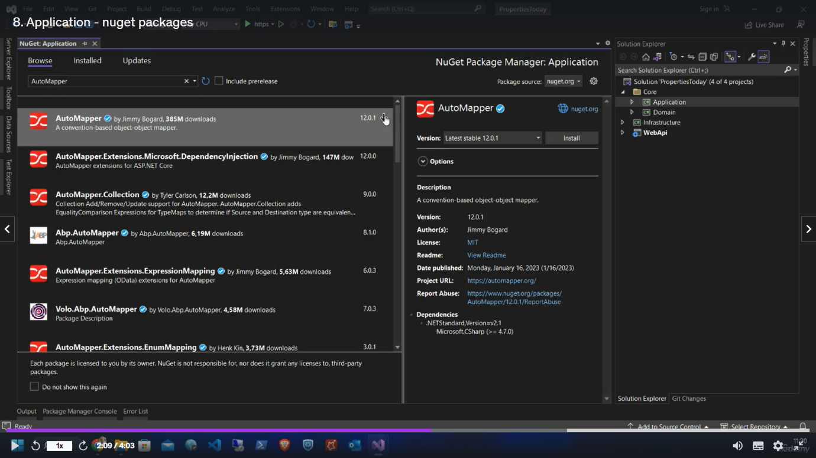

* **Then install AutoMapper.Extensions.Microsoft.DependencyInjection.**

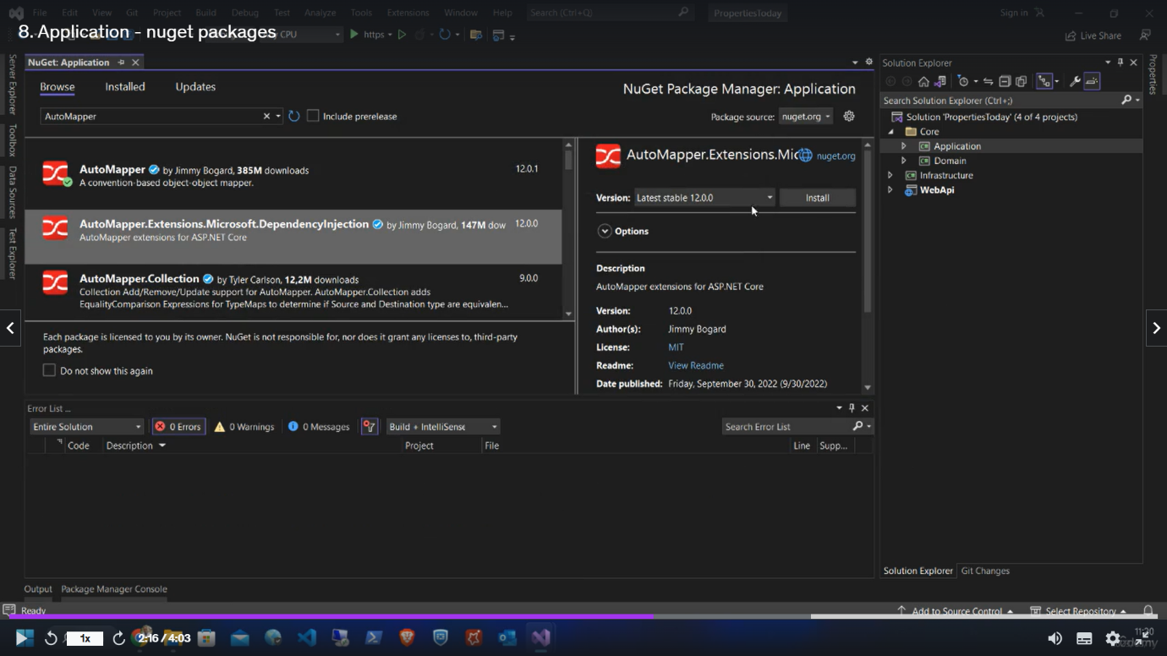

* **Then install FluentValidation.**

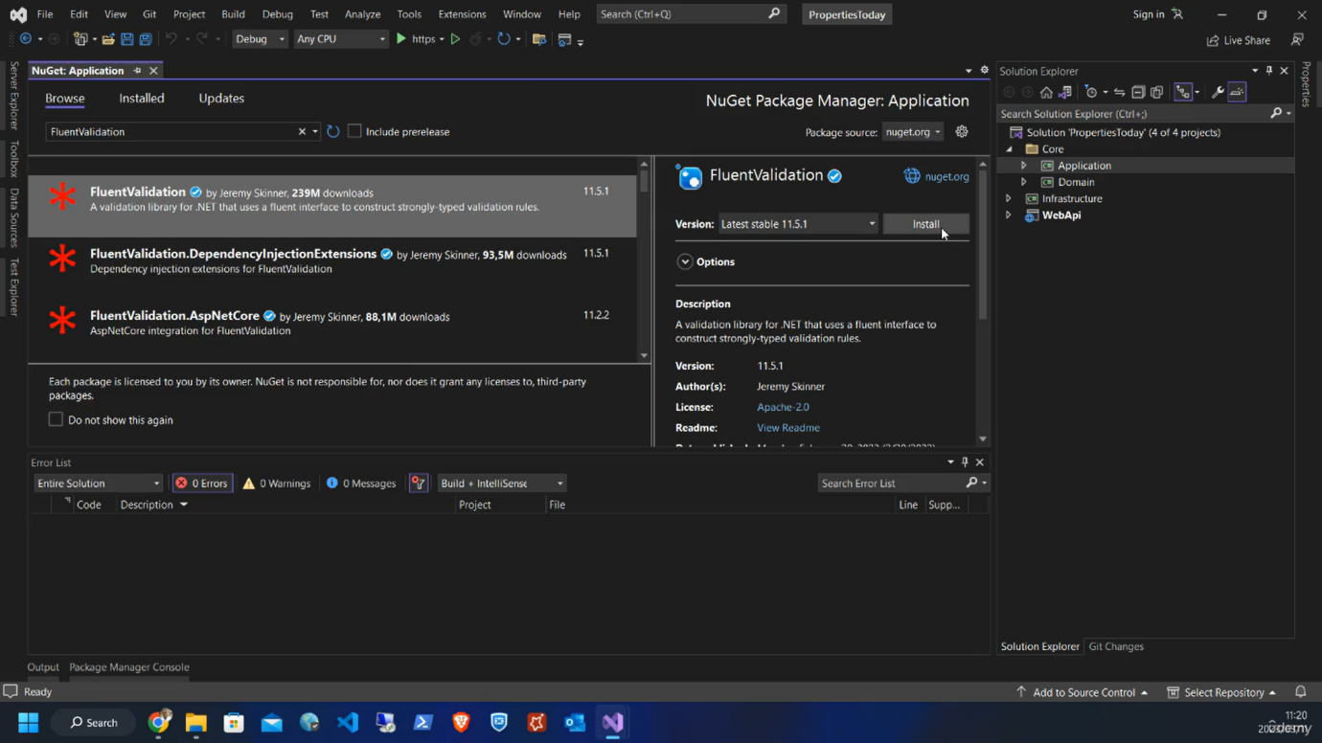

* **Then install FluentValidation.DependencyInjectionExtensions.**

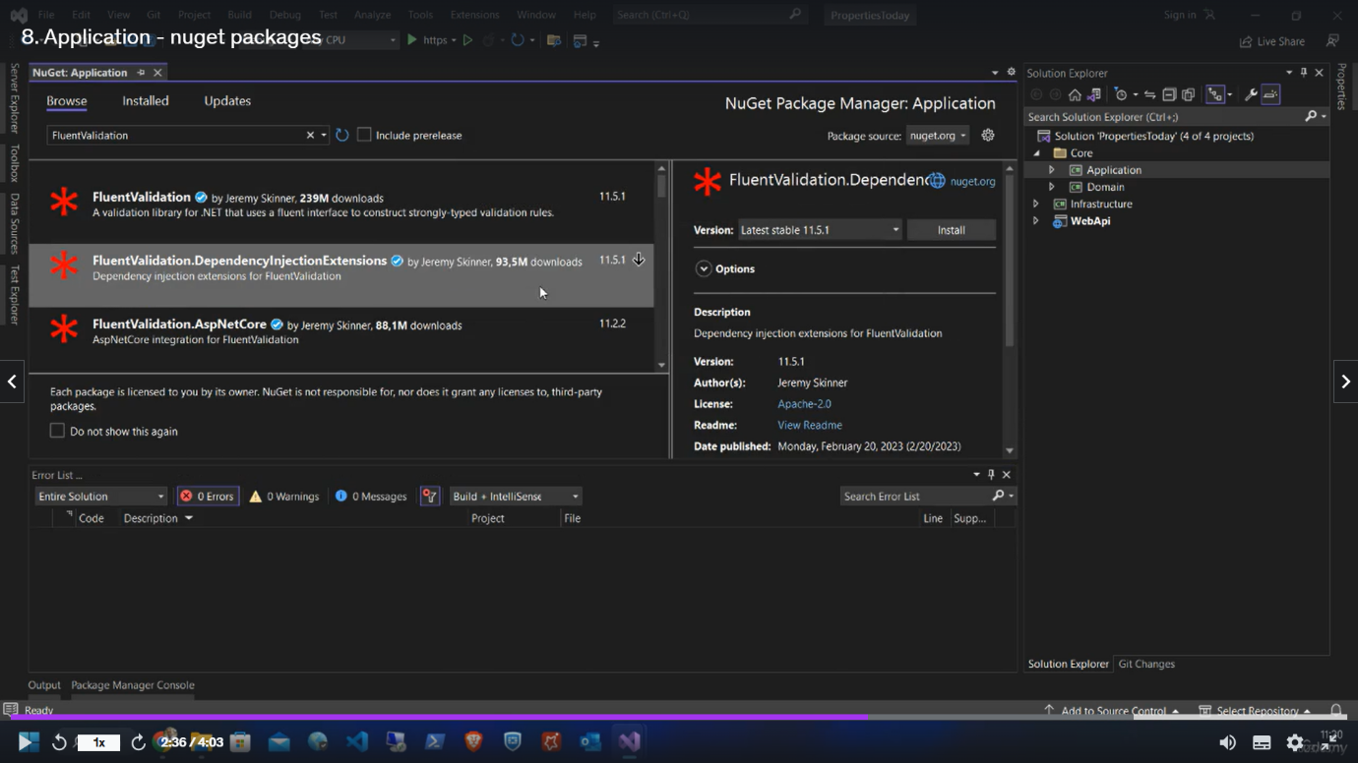

* **Then install MediatR.**

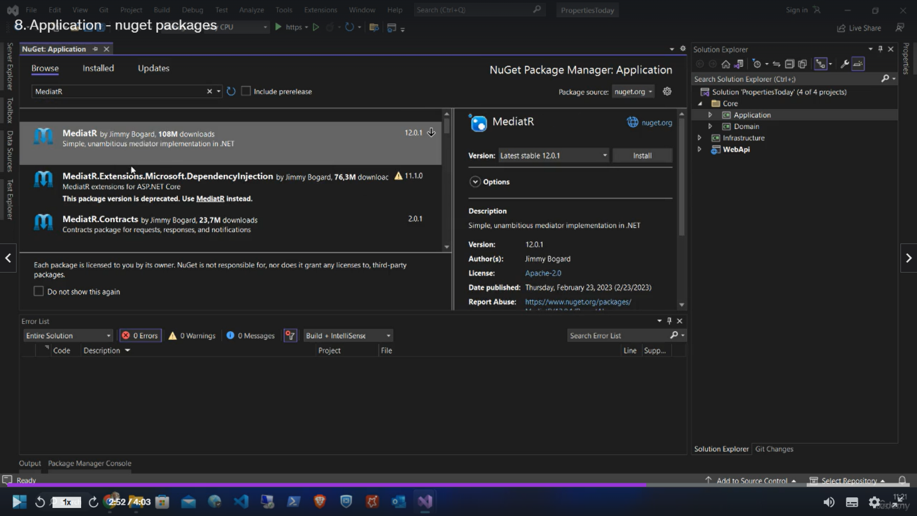

* **Then install MediatR.Extensions.Microsoft.DependencyInjection.**

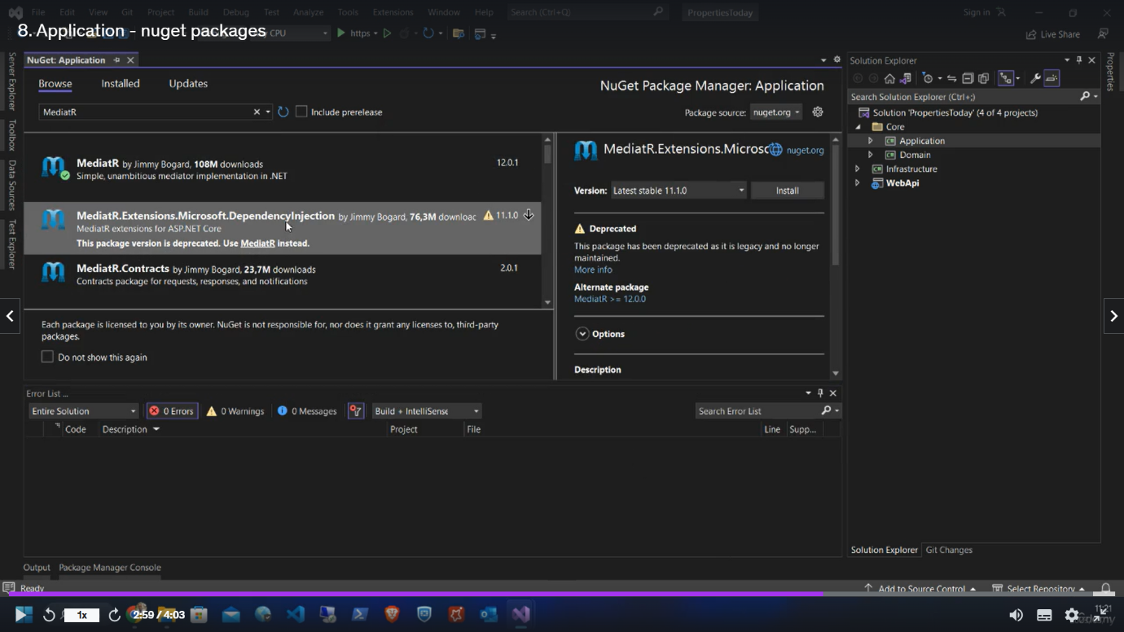

* **Creating Repository**
* **Add new folder in Application layer. The name should be 🡪 Repository.**
* **Inside the repository folder 🡪 add new item 🡪 interface. If adding interface class, then we must add I before the class name eg: IEmployee.**

* **Add new folder in application layer name should be 🡪 Models.**
* **Inside this models folder add a class.**
* add-Migration InitialDbCreation
* update-database